

School of Computer Science & Engineering
Department of Computer Science and Applications

SYBScCS Div -A
Year - 2025-26

Project Based Learning – Project Report
On
“ProjectPals”

Under Guidance of
Prof. Punam Chaudhari



Index
Sr. No. | Contents | PAGE NO.
1 | Introduction | 3
1.1 | Existing System and Need for System | 3-4
1.2 | Scope of System | 4
1.3 | Operating Environment - Hardware and Software | 4-5
1.4 | Brief Description of Technology Used | 5
2 | Proposed System | 6
2.1 | Feasibility Study | 6
2.2 | Objectives of Proposed System | 6-7
2.3 | Users of System | 7
3 | Analysis and Design | 8
3.1 | System Requirements (Functional and Non-Functional requirements | 8-9
3.2 | Module Hierarchy Diagram | 9
3.3 | Database | 10

Team Members

Akshay Shastri– 127224005
Tanmay Deshpande: - 1272240438

1. Introduction
In today’s academic and professional environment, collaboration has become a crucial factor in the successful completion of projects. Modern projects often require a combination of diverse skills such as programming, design, documentation, testing, and project management. However, many students and individuals with innovative ideas face difficulty in finding suitable team members who possess the required technical or creative skills. At the same time, many learners and professionals are highly motivated to work on real-world projects but lack access to the right opportunities or platforms.
To bridge this gap, this project proposes the development of a web-based project collaboration platform. The platform allows individuals or groups to post project ideas along with clearly defined team roles and required skill sets. Interested users can browse available projects and apply to join teams that match their interests and expertise. In addition, an integrated real-time chat feature is provided to enable smooth and effective communication between project creators and applicants, thereby improving coordination and collaboration.

  - Existing System and Need for System

Existing System:
Currently, project collaboration is largely dependent on informal and unstructured methods such as:
- Personal networks including friends, classmates, and seniors
- Social media platforms like LinkedIn, Instagram, or Discord
- Messaging applications such as WhatsApp and Telegram
- Informal online discussion forums and groups
While these methods are commonly used, they suffer from several limitations. There is no proper structure for listing projects, filtering candidates based on skills, or tracking applications. Communication often becomes scattered across multiple platforms, leading to confusion and inefficiency.

Need for Proposed System:
The limitations of the existing system highlight the need for a dedicated collaboration platform. Key reasons include:
- Difficulty in finding team members with specific and verified skills
- Lack of a centralized and organized project listing mechanism
- Absence of a dedicated communication channel for project-based discussions
- Manual coordination is time-consuming and prone to errors
Hence, there is a strong need for a centralized, structured, and interactive system that efficiently connects project idea owners with interested collaborators.

1.2 Scope of System

The scope of the proposed system defines its boundaries and functionalities. The system is designed to:
- Allow individuals or groups to create and post detailed project ideas
- Enable project creators to specify required skills and team roles such as frontend developer, backend developer, UI/UX designer, or tester
- Allow users to browse available projects based on interest and skill set
- Enable users to apply for projects directly through the platform
- Provide a real-time chat system for communication between creators and applicants
- Ensure secure user authentication and safe management of project and user data
The system is scalable in nature and can be extended in the future to support academic institutions, startups, hackathons, and professional collaborations across various domains.

1.3 Operating Environment – Hardware and Software

Hardware Requirements:
- Any standard computer or laptop
- Reliable internet connection
- Minimum 4 GB RAM recommended for smooth operation
Software Requirements:
- Operating System: Windows, Linux, or macOS
- Frontend Technologies: HTML, CSS, JavaScript
- Backend Technologies: JavaScript (Node.js) or Python
- Database: Firebase
- Web Browser: Google Chrome, Mozilla Firefox, Microsoft Edge
The system is platform-independent and can be accessed from any modern web browser.

1.4 Brief Description of Technology Used

The proposed system is developed using modern web technologies that ensure reliability, scalability, and ease of maintenance. Each technology plays a specific role in achieving the overall functionality of the platform.
- HTML (Hypertext Markup Language): HTML is used to design the basic structure of the web application. It defines the layout of web pages, including forms, buttons, text fields, and navigation elements. HTML ensures that content is well-structured and accessible through standard web browsers.
- CSS (Cascading Style Sheets): CSS is responsible for the visual presentation of the platform. It is used to style web pages, control layout, colours, fonts, and spacing, and make the interface visually appealing. CSS also enables responsive design, ensuring that the application works smoothly across different screen sizes and devices.
- JavaScript: JavaScript is the core scripting language used to add interactivity to the platform. On the frontend, it handles form validation, dynamic content loading, and user interactions. On the backend, JavaScript (using Node.js) manages server-side logic, API handling, and communication between the frontend and database.
- Backend Technologies (Node.js / Python): The backend processes user requests, manages business logic, and ensures secure data exchange between the client and the database. Node.js provides fast and scalable server-side execution, while Python offers simplicity and flexibility for backend operations.
- Firebase: Firebase is used as the primary backend service and database. It provides real-time database capabilities, secure user authentication, and cloud storage. Firebase ensures instant synchronization of data such as project posts, applications, and chat messages, making real-time collaboration possible.
- Chat Integration: The integrated chat feature enables real-time communication between project creators and applicants. It allows users to exchange messages instantly, clarify project requirements, and coordinate tasks efficiently, thereby improving collaboration and reducing communication delays.
Overall, the combination of these technologies results in a robust, scalable, and user-friendly collaboration platform.

2. Proposed System
The proposed system is a web-based project collaboration platform designed to overcome the limitations of existing collaboration methods. It provides a structured environment where project ideas can be posted, team requirements can be specified, and interested users can apply based on their skills. The inclusion of a built-in chat system ensures transparent and efficient communication, reducing delays and misunderstandings during team formation.

2.1 Feasibility Study:
A feasibility study is conducted to evaluate the practicality and viability of the proposed system before its development. The feasibility of the project is analysed under three major aspects: technical, economic, and operational feasibility.
Technical Feasibility:
The proposed system is technically feasible as it is developed using modern, widely accepted, and well-supported web technologies such as HTML, CSS, JavaScript, and Firebase. Firebase provides built-in features such as real-time data synchronization, authentication, and cloud storage, which significantly reduce backend complexity. The required hardware and software resources are easily available, and the system can be deployed on standard web servers without any technical constraints.
Economic Feasibility:
The system is economically feasible since it relies mainly on open-source technologies and cloud-based services. Firebase offers free and low-cost pricing plans that are sufficient for academic and small-scale use. There is no requirement for expensive hardware or licensed software, which minimizes development and maintenance costs. Hence, the project can be implemented within a limited budget.
Operational Feasibility:
The proposed system is operationally feasible as it is designed to be user-friendly and easy to operate. Users require minimal training to use the platform effectively. The workflow of posting projects, applying for roles, and communicating through chat is simple and intuitive, ensuring smooth adoption by students and professionals.

2.2 Objectives of Proposed System
The main objective of the proposed system is to simplify and enhance the process of project collaboration by providing a centralized online platform. The detailed objectives of the system are as follows:
- To provide a single, centralized platform for posting and discovering project ideas
- To help users identify projects that match their skills, interests, and career goals
- To assist project creators in finding suitable, skilled, and motivated team members
- To enable transparent and efficient communication through an integrated real-time chat system
- To reduce the time, effort, and manual coordination involved in team formation
- To promote collaborative learning and practical skill development among users
By achieving these objectives, the system aims to improve collaboration efficiency and project success rates.

2.3 Users of System
The proposed system supports multiple types of users, each with specific roles and responsibilities within the platform.
- Project Creators: These users are individuals or groups who propose project ideas. They are responsible for creating project posts, defining required skills and roles, reviewing applications, selecting suitable candidates, and managing communication with team members.
- Applicants: Applicants are users who browse available projects and apply to join teams based on their skills and interests. They can view application statuses, communicate with project creators, and actively participate in selected projects.
- Admin (Optional): The admin user oversees the overall functioning of the platform. The admin manages user accounts, monitors platform activity, resolves issues, and ensures that the system operates smoothly and securely

3. Analysis and Design
The Analysis and Design phase is a critical stage in the development of the proposed system. In this phase, the system requirements are carefully studied, analysed, and transformed into a structured design that serves as a blueprint for implementation. The primary goal of this phase is to ensure that the system meets user expectations while maintaining efficiency, scalability, and reliability.
During analysis, the functional and non-functional requirements of the system are identified based on user needs such as project posting, application management, and real-time communication. This helps in understanding what the system must do and the constraints under which it must operate. Proper requirement analysis reduces ambiguities, minimizes development errors, and improves overall system quality.

3.1 System Requirements
System requirements define the expected behaviour and quality attributes of the proposed system. These requirements are categorized into functional and non-functional requirements to ensure clarity and completeness during development.

Functional Requirements:
- The system shall allow users to register and log in securely using authentication mechanisms.
- The system shall allow project creators to create, update, and delete project postings.
- The system shall enable users to browse available projects based on interests and skills.
- The system shall allow users to apply for projects and track application status.
- The system shall enable project creators to view, accept, or reject applications.
- The system shall provide a real-time chat feature for communication between project creators and applicants.
- The system shall store and retrieve all user, project, and application data from the database

Non-Functional Requirements:
- Security: The system shall ensure secure authentication and protect user data from unauthorized access.
- Performance: The system shall provide fast response times for data retrieval and chat communication.
- Scalability: The system shall be capable of handling an increasing number of users and projects without performance degradation.
- Reliability: The system shall ensure consistent availability and minimal downtime.
- Usability: The system shall provide an intuitive and user-friendly interface requiring minimal learning effort.

3.2 Module Hierarchy Diagram

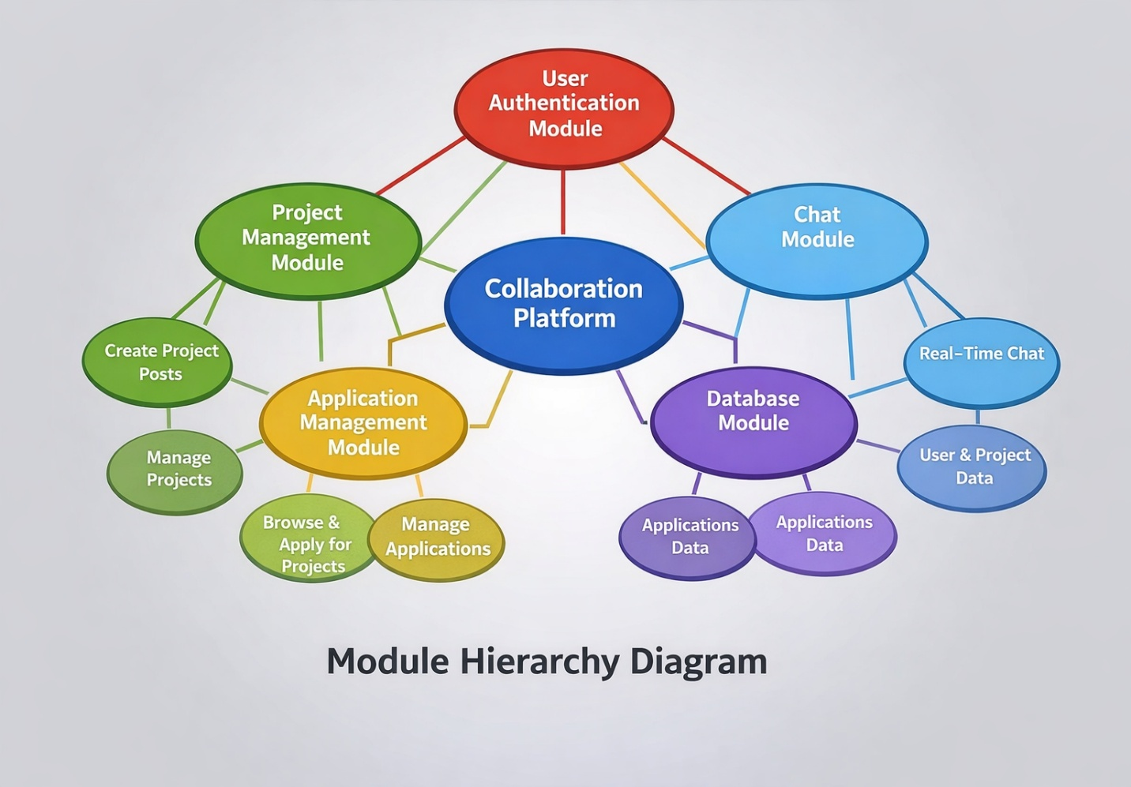

3.3 Database
The database for the proposed system is implemented using Firebase, a cloud-based Backend-as-a-Service (BaaS) platform. Firebase provides a flexible, scalable, and real-time database solution that is well suited for collaborative web applications.
Firebase eliminates the need for manual server-side database management and offers seamless integration with web applications. It supports real-time data synchronization, allowing instant updates whenever a project is created, an application is submitted, or a chat message is sent.
Key Features of Firebase:
- Real-time Database: Enables instant data updates across all connected clients.
- Authentication Services: Provides secure login and registration using email and password authentication.
- Cloud Storage: Stores application-related data efficiently and securely.
- Scalability: Automatically scales with increasing users and data load.

Main Data Collections:
- Users: Stores user profile information, skills, roles, and authentication credentials.
- Projects: Stores project details such as project title, description, required skills, creator information, and project status.
- Applications: Stores application records including applicant details and application status.
- Chats: Stores real-time messages exchanged between users during collaboration.
Firebase ensures secure data storage, efficient data retrieval, and real-time communication, thereby enhancing system performance, reliability, and collaboration efficiency.

